19 December, 2015

ID: | Name: | Section: 01&02
Independent University, Bangladesh
School of Engineering and Computer Science
CSC203- Data Structure
Final Exam, Autumn-2015

Time: 1 hour 30 Minutes Total marks: 40
Answer any two from the following three questions. [2 X 20 marks = 40 marks]

1. | (a) | What is a Queue? Define the class member functions Enqueue () and Dequeue () using a Circular Array based Queue implementation. | 1+5
 | (b)  (c) | Traverse the given tree using Preorder, Postorder and Backward Inorder traversals.  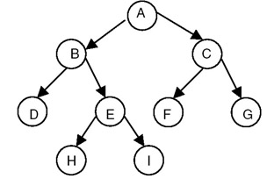  Given the root node of a binary search tree. Write C++ code/ algorithm to display all parent  nodes in ascending order where node’s value is the average of its children.  Assume a node of a BST is defined as follows:  struct nodeBST  {  int data;  struct nodeBST *Left;  struct nodeBST *Right;  };  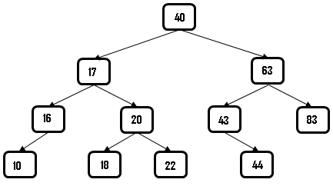  Hints: If the BST as shown above is considered, your program should display 20, 40, 63 (in ascending order) | 6  8
2. | (a)  (b)  (c) | Consider the BST as is shown in 1(c),  - Draw the BST after node value 40 is deleted.  - Draw the BST after operation in (i) and adding node value 39.  Write C++ code/algorithm to sort an array of size n (assume n is even) as the first n/2 integers in ascending order and the rest n/2 integers in descending order using a Heap. [N.B: You can use either max heap or min heap but not both. Also you cannot use additional arrays to solve this question.]  Example:  input n=12 elements are:  After sorting and reordering output n=12 elements are:  What is priority queue? Explain your opinion to implement priority queue using Heap data structure. Assume you already have heapify-down/downheap and heapify/upheap functions available. | 5  10  1+4
  14 | 55 | 1 | 12 | 26 | 21 | 9 | 84 | 17 | 62 | 2 | 3
  1 | 2 | 3 | 9 | 12 | 14 | 84 | 62 | 55 | 26 | 21 | 17
3. | (a) | Assume root node of a tree is given. Write C++ code/ algorithm to determine the highest depth of the tree. [Hints: The tree on Question 1.(c) has highest depth 3] | 5
 | (b) | Given the graph as is shown below and a starting vertex A, traverse the graph using BFS and DFS traversal order. [Follow alphabet order, i.e. ‘B’ comes before ‘C’ while a node has multiple links.]  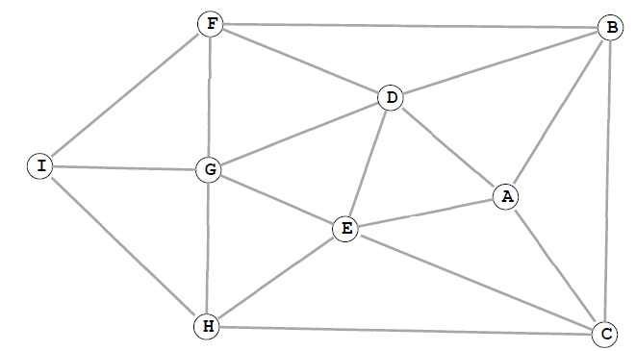 | 5
 | (c) | Given a graph with two vertices ‘A’ and ‘I’. (You may assume the graph on Question 3(b) for example.) Write C++ code/algorithm to generate and display the traversal path (from ‘A’ to ‘I’) using BFS algorithm. | 10

